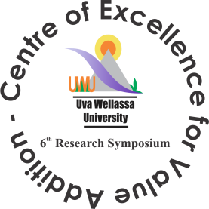
Uva Wellassa University
6th Research Symposium
“Towards Emerging Trends in Value Addition”
28th & 29th January 2016

Registration Form
Presenter/ Participant Information
Title | Rev./Prof./Dr./Mr./Ms.
Name with initials
Full Name
Designation
Organization
Postal Address
Country
Telephone
Fax
E- Mail
Participation | Oral |  |  | Poster |  |  |  | Participant
Category | Student |  |  | Local |  |  |  | SAARC
Meal Preference | Vegetarian |  |  | Non-Vegetarian |  |  |  | No meal
Title
Payment method | Bank Draft No |  |  |  | Cheque No
(Drawn in favor of “Uva Wellassa University of Sri Lanka)
Payments should be made to the Bank of Ceylon
Account No: 3114820 at Badulla Branch

Signature Date

Address:
Dr. P. I. N. Fernando
Symposium Coordinator
Uva Wellassa University
Badulla 90000
Sri Lanka

Email: symposium@uwu.ac.lk Web: www.uwu.ac.lk

